**Active Recon – Nikto & Dirb**

**Nikto**

Can be used when stealth isn’t necessarily required

Provides a good base of information for what a website has available

* PHP
* Wordpress
* Put method

Functions

* Nikto -h <address>

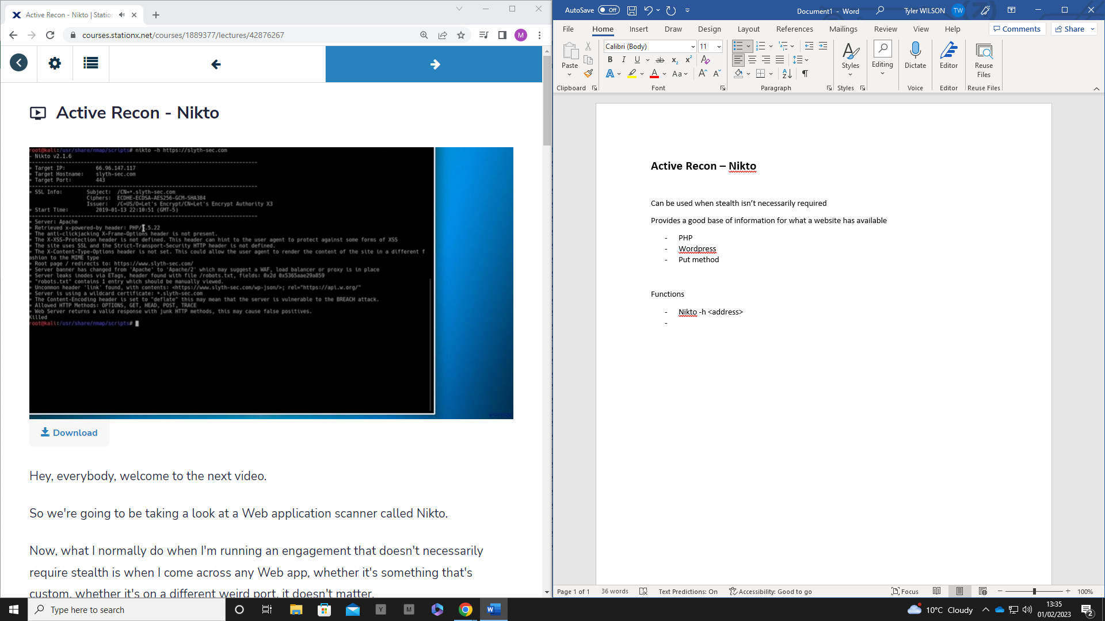

Details on:

* Server
* Cross- site protection
* Ciphersuite
* Root page
* Wordpress version
* Content header
* Put method

Wpscan – word press scanner

**Dirb**

Allows you to check the directories based on a word list

* For each word, it makes a connection
* Can use this to check for hidden directories